Four Steps to Survive Evolution

Four steps for surviving evolution classes at high school

First published: 4 July 2015 (GMT+10)
Re-featured on homepage: 11 November 2020 (GMT+10)
Today’s feedback comes from RL of Australia, asking about how to deal with their classes on evolution at High School.
iStockphoto
We are learning evolution in school (year 10 science), and I would like some handy get-to-the-point questions I can ask my science teacher to make him/her think. We are currently learning about adaptations, genes and DNA. Perhaps some questions about the animals that have structural and functional body parts which help them survive in their environment. My teacher has also mentioned ‘natural selection’ and I’m not quite sure how to answer that. He also believes that all animals evolved from sea animals. He asked us why we thought they decided to come on to the land. He is also mentioning the shape of all the animals and how this helps them survive.
CMI’s Dr Tas Walker responds.
Dear RL,
Remind yourself that they are just telling you a story.
One of my granddaughters also had to learn about evolution in year 10 science. Actually, evolutionary ideas are taught from a much younger age, and they are not always obvious. When young people first encounter these new ideas, it can come as a shock and be quite upsetting. I gave my granddaughter four points to help her survive and thrive in her studies. I’ll mention these to you, too.

1. Remind yourself that they are just telling you a story
When your teacher is saying things like, “All animals evolved from sea animals” you just have to remind yourself that he/she is telling you a story. Don’t let it upset you. Remember that science is based on observation, and these stories were not observed. This is something to tell yourself; so you don’t get upset, stressed, or confused.
Remember that there are two basic stories to explain how this world and everything else came into being.
The first is in the historical record of the Bible. An outline of the events is:
- Creation in six days about 6,000 years ago,
- the Fall,
- the Flood about 4,500 years ago,
- the Tower of Babel about 200 years after the Flood,
- the call of Abraham and the history of Israel,
- the coming of Christ,
- the birth and growth of the church, leading up to where we are now.
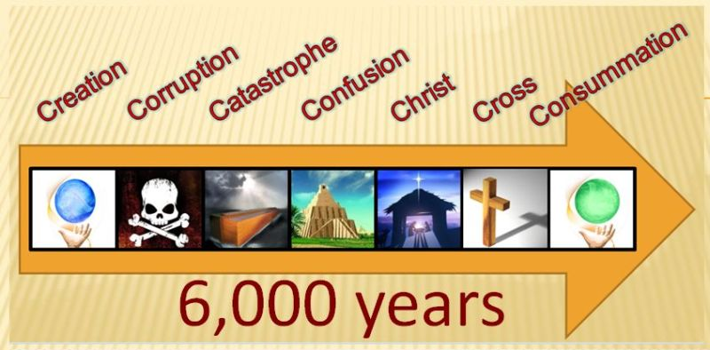Outline of main events of biblical history
A key point is that the events recorded in the Bible are historical, which means they are based on eyewitness accountsof people who were present and saw them happen.
The second story, which is taught at your high school, is evolution. An outline of the main events is:
- Big bang followed by cosmic evolution beginning ~14 billion years ago
- Formation of the earth about 4,500 million years ago and its subsequent geological evolution
- Origin of life some 3,500+ million years ago
- Biological evolution: fish to amphibians to reptiles to mammals to apes to humans.
- Human evolution: apes to humans
- Cultural evolution: humans as hunters, farmers, builders, artists, invention of religion, civilization
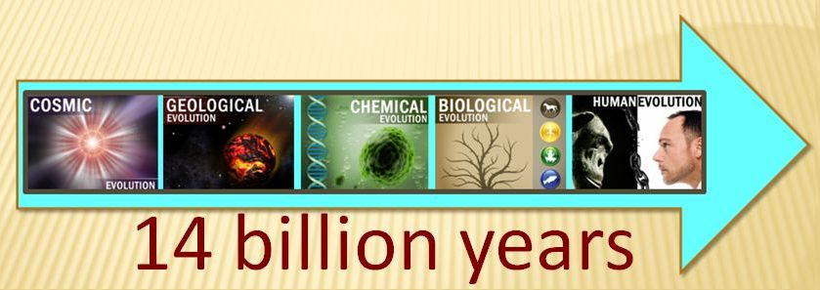Outline of main events of big-picture evolution story
The key point about this story is that these events were not observed. No one saw these things happen. Every part of this story was invented by people who were not there. And the purpose of the story is to explain things by natural processes. God and the Bible are banned from the story.
So when your teacher or the textbook tells you that all land animals came from marine animals, etc., just remind yourself that they are telling you a story. And the reason they are telling the story in this way is because they have to explain the animals without God. That means the land animals had to evolve with very small changes from other animals over millions of years. And since, according to their thinking, the first living cell could not have arisen on the land, it had to originate in the ocean. So they conclude that life must have evolved in the ocean and eventually come out on to the land.
It’s all just a story fitted together by human logic, assuming the Bible is not true and there is no God.

2. Don’t feel that you have to prove that creation is true
Another way of saying this is, “Don’t take on yourself the burden of proof”. This will take all the stress out of your life. You don’t have to feel responsible to do something that you don’t feel you are equipped to do.
Don’t take on yourself the burden of proof.
You don’t have to prove them wrong. You don’t have to prove you are right.
Put the burden of proof on to them, and make them try to prove it to you, which they won’t be able to do.
Consider the situation when your teacher says, “All animals evolved from marine animals.” It’s not a good idea to say, “I don’t believe that because I believe the Bible.” He/she will dismiss you as being religious. Then, he/she will humiliate you by saying that evolution is based on facts and evidence, but your religion is based on faith. So, don’t say you don’t accept evolution because you believe the Bible.¹
Instead, focus on the evidence. Just keep saying things like: “Can you give me any evidence for that?” or “I don’t want to accept these claims on faith”, or “That does not make sense to me”, or “I don’t find that convincing”.
And when they do try to give you evidence, think about what they have said and ask them more questions about the evidence, as discussed under Point 3 in the next section.
These are the sorts of questions that you asked about in your email—handy get-to-the-point questions you can ask your science teacher to make him/her think. You see, when you engage the subject like this, your teacher will be impressed that you are thinking about and understand the subject, and this may be the first time he/she has been asked to present evidence.
So, develop the practice of asking questions about the evidence and about the interpretations presented to you by your teacher and the textbooks. This will put you in the driver’s seat.

3. Ask yourself, “What did they actually see?”
You need to think about what is being presented in class, and be careful not to dismiss automatically everything your teacher and textbooks say. Although they will present you a lot of evolutionary nonsense, they will also present plenty of good information. You need to learn how to sort out fact from belief.
You sort out fact from speculation by asking, “What did they actually see?” Another way of putting that question is, “What is the actual evidence for that?” Science is all about observation, and so you are just asking for the scientific evidence. In a science class, who can criticize you for that? You can ask the question of yourself as you read your textbook, or when the teacher presents some information. This will clarify the issue in your mind. Or you can ask it of your teacher or your fellow students. This question will empower you to sort out the confusing information you are presented with.
The teacher might show you a picture of a fossil fish with long fins and say it lived 300 million years ago and evolved into land animals because it walked on its long fins.
Ask yourself, “What did they actually see?”
You ask yourself, “What did they actually see?”
- They saw the fish. They can tell you where they found it. They observed what the fish looked like, and the shape of its fins.
- But the fish did not have a label on it saying “300 million years old”. So you can know that the date they quote is not based on observation but on their beliefs.
- Neither did they see the fish walking on its fins, so that is also speculation.
- Nor did they see it come out on to the land, so that is an invention too.
This question is powerful and will help you understand what is factual and what is guesswork. It’s a question that you can use in your discussions with your teacher and your friends.

4. Keep learning and keep getting informed
When you first encounter evolution in your class you will probably know very little about it. Your teacher will be much more knowledgeable and experienced than you. However, by using the above strategies you will be able to survive and be confident. But you need to grow and develop. There will always be new issues and questions that you will encounter, which means you will need to keep learning. You will find creation.com very helpful. It has a great search engine where you can investigate the claims from your teacher and your textbooks.
You can easily find articles by searching for keywords, which in your case would be: adaptations, genes, DNA, natural selection, animal similarities, etc. In a discussion, if you do not know the answer, you can always say, “I’ll do some research about that and get back to you.” Then you will almost certainly find the issue answered on creation.com, which you can print out and later give to the person to whom you are talking.
A helpful book is Refuting Evolution by Jonathan Sarfati, which can be bought from the online store. It is aimed exactly at what they are teaching you at high school. It’s also available free online.
If you are not already subscribed you will find the email newsletter useful in helping you become informed. You can connect from the front page of the website. Also, if you do not receive Creation magazine, that is a great resource for ongoing learning.
As far as your year 10 course is concerned, the articles “They are teaching lies to our kids” and “They’re teaching racism to our kids” deal with some of the specific material in your textbooks. The articles deal with many topics and provide links to other articles for more in-depth information.
Concerning your comment on animal shape, the article “Are look-alikes related?” answers that question. Especially check out the similarities between placental and marsupial animals listed in the table in this article because they provide a powerful argument for design and against evolution.
Thanks for your email. I wish you all the best with your studies.
by Tas Walker
Scientist, writer, speaker
Facebook Twitter Reddit LinkedInParler Email

Related Articles
- They are teaching lies to our kids
- They’re teaching racism to our kids
- Are look-alikes related?
- Does homology provide evidence of evolutionary naturalism?
- ‘How do I do my assignment about evolution?’
- Seven ways to build a lighthouse

Related Media

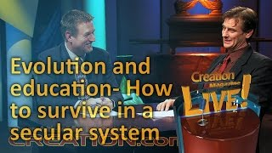
Evolution and education- How to survive in a secular system

References and notes
- It’s true that we don’t believe in evolution because it contradicts the Bible. However, it is also true that evolution is contradicted by the scientific evidence. By not mentioning the Bible you are not being sneaky because their belief in evolution is also driven by their beliefs about the Bible. That is, they believe in evolution because they do not believe the Bible. It will be easier for you to avoid the philosophical issues involved here. First, they probably will not understand them, and second, they may latch on to any chance to dismiss you. Return to text.
View All

Helpful Resources
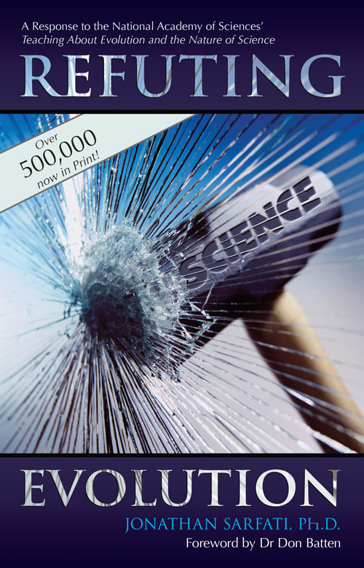
Refuting Evolution
by Jonathan Sarfati
£ 6^{.50}
Soft Cover
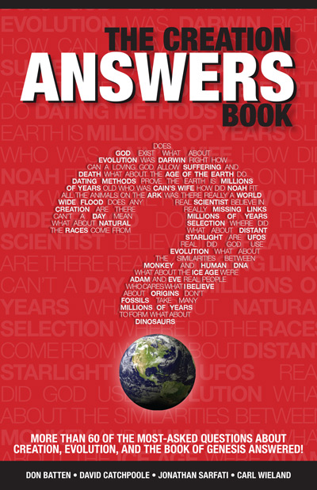
Creation Answers Book
by Various
£ 8^{.50}
Soft Cover
Error! Filename not specified.
Evolution's Achilles' Heels
by Nine Ph.D. scientists
£ 10^{.00}
Soft Cover

Readers’ comments
Rev Ian C.
GB July 17th, 2015
I always tell my young people that there is another story besides the one they are fed in school.
When they are going to University I tell them never to accept at face value what they are told; always ask yourself, 'How do we know that', and then apply the research tools you are being taught.
Brian M.
GB July 17th, 2015
A helpful article & comments following, thank you. I like the direct question 'What did people see?' and was a little puzzled why the word 'observed' was not included in the alternative question for evidence or measurement?
Tas Walker
July 17th, 2015
That is one way of saying it. The word observation is used in that section.
C. H.
AU July 15th, 2015
These are excellent ways of helping a student to navigate high school and Uni science. I used similar strategies when I studied geography at Uni and was forced to regurgitate 'billions of years' textbook answers.
(As a mum of 6, though, I often tell people that if evolution was real then women would have evolved a zipper in their lower abdomen & uterus for easy birthing, an extra two arms, and eyes in the back of the head.)
Brad W.
US July 12th, 2015
> what does the student answer to test questions which demand an evolutionary answer?
I ran into this when I was in college. I had already been respectfully asking clarifying questions during the course up to that point, so I'd laid a foundation of mutual respect, not confrontation. I was the only one, out of 150 in the class, that he knew by name. When we got to the test, I went to his office and asked him how he wanted me to handle it. "What do you mean?" I gave an example of a question for which I doubted that the correct answer would be one of the multiple choices. I was clear that I was under his authority in this class and was willing to take any approach he wanted.
His novel solution was for me to answer the ones I could and leave the others blank. Then to hand it in separately, not in the stack with all the others. I marked in the margin the textbook answers to the other questions, to show I had been paying attention. He gave me an A even though I only answered half the questions.
Frank G.
AU July 10th, 2015
I am a little uneasy criticizing "evolution" since, in conversation, most people associate with the data and science that supports variation and adaption - which both Darwinists and Creationists are in broad agreement!
The point of difference that makes the point for me is the question of the number of common ancestors - ie one or many.
Thus the conversation turns to the relevant evidences and processes or lack thereof.
It also invokes the philosophical problem of the beginning - was it God, or did nothing miraculously become something - either way, a "super-natural" process.
Tas Walker
July 10th, 2015
You can make a lot of progress just by asking for evidence, things that can be observed and measured. You don't have to cricticise when they can't provide the evidence.
Sherwin D.
US July 10th, 2015
I have written questions to evolutionist with never a reply.
I asked them when man or an animal evolved , what came first. Was it an arm? A head? Maybe a gall bladder. How about a heart.
My point was, the brain,heart ,lungs,veins,and all organs and bacteria etc must be there at the same time to be able to live. Did animals hop on one leg first? Or maybe in a million years we will have a 3rd arm which will be helpful. The evolutionist is not even worth debating. Makes more sense to debate a flat earth ideology!!!
Burnie J.
AU July 10th, 2015
I would like to recommend Jonathan Sarfati By Design it is a bit complicated but some stuff is easy to understand
R. R.
NZ July 7th, 2015
I followed much the same strategy to survive studying theology at a theological faculty where humanistic philosophy formed the basis of what was taught. It worked, but was still extremely unsettling to survive emotionally when the truth of God's Word is blatantly undermined. Your good work is highly appreciated!
Louis G.
GB July 6th, 2015
In this article, the Big Bang is presented as the non-Biblical version of the origin of our world. Do not many Christian scientists believe in the Big Bang because of the evidence from background radiation, the expanding universe, etc. ? They say that it proves Creation, as it shows that the universe has a beginning. Do you reject this evidence for Creation? Did not many turn towards religion once realizing that the previous steady state theory was disproved and the beginning (Genesis) was proved from the Big Bang? Do you say that the steady state theory is still not scientifically disproven? How else can one explain the measured background radiation that so many Christians say proves Creation?
Tas Walker
July 7th, 2015
There are a couple of aspects of the big bang scenario that provide support for creation: 1. it has a beginning which suggests the need for a creator to begin it, 2. it requires finely-tuned parameters which point to a designer. However, the details of the big bang do not agree with biblical history as illustrated in the first diagram above. Just make the comparison yourself between the two scenarios. You don't have to take anyone else's word for it.
Further, the so-called 'proofs' of the big bang, such as the background radiation, turn out not to be proofs at all. Search 'big bang' in creation.com searchbox and you will find many articles, such as Exploding the big bang and Did God use the big bang?
Cowboy Bob S.
US July 5th, 2015
Every once in a while, I am asked about how Christian students should prepare for evolution storytime. Dr. Walker made some excellent points here, and I am looking forward to not only sharing this, but keeping it handy for future reference.
'Ask yourself, “What did they actually see?”' is very important, because they will take observed facts and then tack on arbitrary assertions to praise evolution. Two creatures have some resemblance, here are some actual facts, therefore, EvolutionDidIt. Wrong.
The final point is one I've made as well, and people are surprised. But people do need to know the prevailing viewpoint even though it is false, so they can learn the truth and remain undeceived through critical thinking as well as Scripture.
Hans G.
AU July 5th, 2015
Those are tips how to ask questions during teaching but what does the student answer to test questions which demand an evolutionary answer?
Tas Walker
July 5th, 2015
Those are tips about surviving at college and school. The big danger is that a person will fall for the deception being presented in class, and these tips are about how to personally survive and thrive.
With exams it's easy for essay type exams. The student just prefaces their answer with words like, "According to the concpept of natural selection ...", or "Modern evolutionary theory holds that ...". The student is demonstrating that they know the material taught, but they are not saying that they believe it.
For multi-choice questions there will usually not be a suitable option. In this case I think the student just selects the answer that the lecturers want.
Christine D.
AU July 5th, 2015
Thank you for this clear and simple set of guides that are "spot-on". I will be reviewing them with my daughter who has started High School this year and is already being exposed to the "goo to you" storytelling in her science classes.
Chris W.
GB July 4th, 2015
I think there needs to be another point inserted so as to make 5, because the teacher will fall back on ''we know that'' or ''we can test and measure that'', and then go on to talk about radiometric dating. The student then needs to be able to lucidly mention about the assumptions made when radiometric dating takes place.
Tas Walker
July 4th, 2015
Yes, it is helpful to understand the way radioactive dating works, and that is covered in Point 4 to keep learning. In the meantime, for someone with limited experience Point 3 would help them through. Asking what they actually saw can help a person survive when something entirely new is introduced that the student has not heard about before. In the examples you mentioned they simply need to ask the questions: "How do you know that?" and "What did they actually measure?" to appreciate that they are not actually measuring the age of something.
Jack M.
GB July 4th, 2015
It always puzzles me when the Bible is described as 'based on eyewitness accounts of people who were present and saw them happen.'
Take, for example, the first 26 verses of Genesis and ask yourself the question 'What did they actually see?'
Tas Walker
July 4th, 2015
The first human witness were present on the sixth day of Creation Week. Before that God was present and it is not unreasonable to assume He discussed this with Adam prior to the Fall during the sorts of fellowship times suggested by Genesis 3:8–9.
Steve S.
US July 4th, 2015
Generally most will agree that life is amazingly well designed (operational)—just beware of the homage to the false god of evolution (history of deep time and death), as they conclude it was "evolved."
Warren C.
AU July 4th, 2015
I've recently retired as a general primary school teacher in the public system, and I used similar recommendations to my my older students (particularly over the last one or two decades as evolution became popularly accepted as truth rather than a very wobbly theory). It was often a surprise to hear how stridently young children would resist any questioning of their very firmly formed opinions/beliefs about evolution. Presentations by David Attenborough in particular seem to be swallowed hook, line & sinker without question, and used as a point of reference in several discussions and lessons.
God bless your faithful persistence in this crucial area of education!
Ashley M.
AU July 4th, 2015
Fantastic advice. I really appreciated the encouragement to respect teachers. Not everything they say is nonsense. Very refreshing read.
Dean R.
AU July 3rd, 2015
Yes amen to scientific models & world views that challenge the mathematical consensus of goo to you, often unexplained but often inferred without ever giving the other side of the story.
Let there be light in education & science, freedom to grow & learn about God's wonderful creation & powerful redemption.
H. S.
AU July 3rd, 2015
My son is in Grade 10 too. Thank you for sharing advice for our students in a clear and helpful manner.
Don H.
AU July 3rd, 2015
How ingenious. I think that this has to be one of the best recommendations I have read. I work at a Christian College and the teachers there are wonderful..... and Christian. This article will be going to my secular family and their children.
God has certainly blessed your work.
Richard G.
JP November 10th, 2020
No one can be prepared to win every argument. And what student can stand up to their teacher (or other opponent) in class or in private or in an exam? The problem is only solved by asking God to give the wisdom to act or answer properly in every case. You can't tell me that you're all so bold (and knowledgable) as to take on all Satan's advocates. The top student in our school (Dux) was weak but he held to Jesus who said He is the Truth and he succeeded. Ask God to help.
Some hints. Even if evolution and its no God basis were true, it offers me nothing, especially after death. Therefore don't waste much time examining evolution's side. Settle it with yourself whether the Bible is true. Study it thoroughly. "Pray without ceasing." 1 Thess 5:17. Stress (and enjoy the fact) that the Bible has been the world's best seller and that until a person can equal the Bible they have no authority or weight with you. (Stick to your idea even if they say 'The Bible sells well because it says what people want to hear.' To write the best would require them to be able to change 85,000 selfish people every day as the Bible does, and they must be able to tell the future with 100% success as the Bible has done.
My hobby in 60 years of church-planting in Japan is the agreement of the Bible and true science. I love CMI's science! Staggering! But it's only a hobby! I already have assurance because Jesus made me happy( and drastically improved) ever since I received Him at 17. People accept evolution because it allows them to live selfishly not because it's true. It's Satan's big lie! The positive influence of godly parents (not well-educated ones!!) shut out evolution's no hope. And if the Bible is the true one then evolution and its bedfellows are leading us to eternal doom.
David S.
SG November 11th, 2020
I believe another way would be to treat all classes on evolution like you were in a literature class where a fictional novel or something like Greek mythology is discussed. Learn everything about it and reproduce it in assignments and examinations without having to believe it. Do all this, if you want to avoid being embroiled in defending your private beliefs and scepticism of evolution. This could get pretty nasty in some cases. Besides, a detailed study of evolution will inevitably provide more ammunition for scepticism. Also, we need to keep in mind that science has been shown not to provide established facts but a temporary resting place until another scientific paradigm comes to upset everything e.g. Newtonian science by Einstein.
Lewis John G.
ZA November 11th, 2020
I would encourage Christian parents to home-school or become active in establishing a Christian Day School.
That should remove the problem that parents might face regarding how to deal with evolution taught in state schools.
Chuck R.
US November 11th, 2020
Just as you noted at the beginning of your reply to RL that indoctrination into evolution begins at a much earlier age than year 10 science, an example would be using the fascination of dinosaurs to promote millions of years in kid books, and is very likely why Brad W. was the only one of 150 to question the 'science' being taught in college.
If we as parents wait until year 10 science, we are likely too late to counter the indoctrination.
"Train up a child in the way he should go."
Gina T.
NZ November 11th, 2020
Thank you once again for providing us with excellent answers, and most importantly for reminding us of the need to have a respectful attitude when challenged for our stand on Creation. I'm reminded of the last bit of 1 Pet 3:15 where we are to present God's truth "with meekness and fear."
In keeping with this last point, it is with great trepidation that I wish to gently add that an important element that was missed in this otherwise excellent article! We really need to remember that we wrestle not against flesh and blood (Ephesians 6:12). The evolution model is a well established stronghold, masterminded by the enemy of souls. We cannot battle against Satan with apologetics and robust scientific argument alone. It is only through earnest prayer and firm faith that we can hope to pull down the powerful stronghold that evolution has over the western education system. 2 Corinthians 10:4 and Ephesians 6:11&13 sit together wonderfully. Establishing the "whole armour of God" is Base One. We need to prepare our hearts with these weapons first and foremost, and to pray for those who are teaching evolution. Once this is established, then we can proceed to apologetics.
Andrew B.
AU November 12th, 2020
Ask the basic questions:
* Can life start by itself? (No evidence.)
* Can nothing become matter (universe), by itself? (No evidence.)
* Do complex informational codes (e.g. DNA), create themselves? (No evidence.)
* Does the fossil record show gradualism? (No - even Dawkins and Gould admit that.)
Just be aware that the school system is a poisonous environment.
Even SRE teachers are removed from school for dismantling evolution. I should know - I was removed (as SRE teacher with 20 years SRE experience) from Mosman primary school (year 5) for answering their questions on evolution, by discussing the real world science (above) during the SRE classes. I have BSc and BE degrees. The class teacher (a staunch evolutionist) was given several opportunities to look at the evidence afterwards (she refused) and she was given the book "Darwin's Black Box - Michael Behe" but she refused to read it. She interrupted my SRE lesson several times, by shouting from the back of the classroom that evolution was true. Then she had me removed from the school. The evolution battle has nothing to do with evidence - people simply don't want to acknowledge that God is the Boss. Hence, there is a Judgement Day.
David P.
GB November 13th, 2020
I'm so glad that Creationism is not allowed to be taught in UK schools. It lies in the realms of folklore and storytime for five year olds. Adults can make up their own minds but impressionable children need to be taught the scientific method of study, research and analysis based on centuries of learning. Your hilarious tales negate virtually the whole of physics: this will cause conflicts with the science they will learn in biology, genetics, DNA, geology etc ad infinitum. But please don't stop: when I'm really bored and need cheering up then I turn to this website to seek what fresh buffoonery you have dreamt up to explain the latest fossil or cosmology that has been discovered.
Tas Walker
November 13th, 2020
... since the creation of the world God’s invisible qualities—his eternal power and divine nature—have been clearly seen, being understood from what has been made, so that people are without excuse. Romans 1:20

